Q1:
CREATE TABLE employee (
ID INT PRIMARY KEY,
person_name VARCHAR(25) NOT NULL,
street VARCHAR(70),
city VARCHAR(25));
CREATE TABLE company (
company_name VARCHAR(25) PRIMARY KEY,
city VARCHAR(25));
CREATE TABLE works (
ID INT,
company_name VARCHAR(25),
salary DECIMAL(10, 2),
PRIMARY KEY (ID, company_name),
FOREIGN KEY (ID) REFERENCES employee(ID),
FOREIGN KEY (company_name) REFERENCES company(company_name));
CREATE TABLE manages (
ID INT PRIMARY KEY,
manager_id INT,
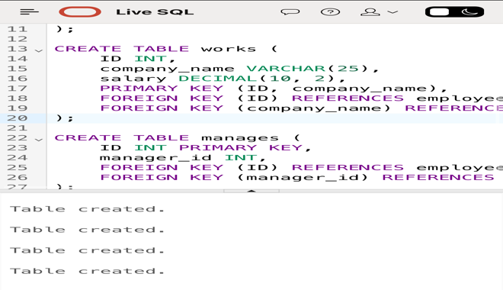
FOREIGN KEY (ID) REFERENCES employee(ID),
FOREIGN KEY (manager_id) REFERENCES employee(ID));
Q2:
1) SELECT ID
FROM depositor
WHERE ID NOT IN (SELECT ID FROM borrower);

2) SELECT ID
FROM customer
WHERE customer_street = (SELECT customer_street FROM customer WHERE ID = '12345')
AND customer_city = (SELECT customer_city FROM customer WHERE ID = '12345');

3) SELECT branch_name
FROM branch
JOIN account ON branch_name = account.branch_name
JOIN depositor ON account_number = depositor.account_number
JOIN customer ON ID = customer.ID
WHERE customer_city = 'Harrison';

Q3:A) SELECT day,qty,
SUM(qty) OVER (order by day) AS cumQty
FROM demand_table;

B) SELECT product, day, qty ,RN
FROM ( SELECT product, day, qty,
RANK() OVER (PARTITION BY product ORDER BY qty ) AS RN
FROM product_sales)
where RN<=2;

